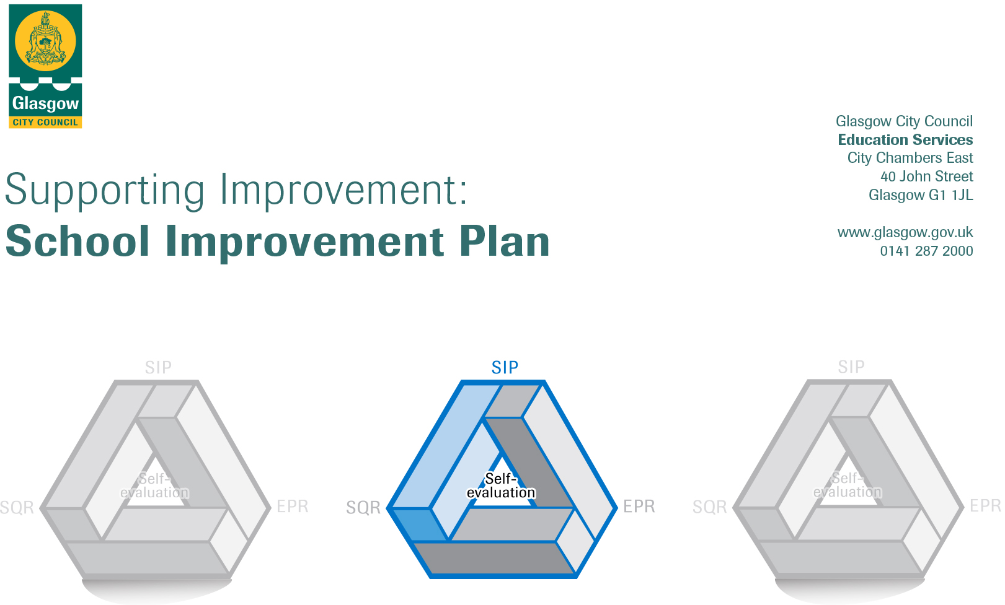

Establishment |  | SCOTSTOUN PRIMARY SCHOOL
Head of Establishment |  | GILL MACKAY
Area/Local Improvement Group |  | NWLIG2
Head of Service |  | JIM WILSON
Area Education Officer/  Quality Improvement Officer |  | From August 2020 DAVID BYRNE QIO

CONTENTS
1. Vision, Values and Aims
2. Summary of Self-Evaluation Process / Priorities for Improvement in the current session
3. Action Planning

Action Plan Summary for Stakeholders

1. Our Vision, Values and Aims
VALUES
Respect, Learning, Community, Happiness
VISION
Scotstoun Primary School is committed to promoting diversity and global citizenship and to equipping pupils with the skills to meet the challenges of the 21st century. By delivering a curriculum that promotes skills for life encompassing literacy, numeracy, ICT and health and well-being; along with independence, responsibility and motivation.
AIMS
- To recognize and develop every child’s potential across the curriculum and to maximize achievements in all areas, particularly in literacy and maths.
- To encourage and develop the expertise of staff and to provide a stimulating learning environment for all school users.
- To provide a curriculum and ethos promoting inclusion, health, welfare and equal opportunities for all.
- We aim to foster respect, good citizenship skills and attitudes within the school, working in partnership with parents, pupils and the wider community.

2. Summary of our self-evaluation process DURING 2019/2020 and START OF 2020/21
During sessions 2018/19 and 2019/20 we carried out surveys based on the HMIE questionnaires for parent/carers, staff and pupils.
During 2019/20 we also had comments boards and evaluations at Nurture workshops, Open Evenings and for RSHP. We routinely carried out evaluations and asked for feedback at our workshops, clubs and family events.
We also evaluated our PEF funding impact and reported on our attainment and school improvement through the Parent Council, NWLIG2 trios and the Glasgow Improvement Challenge. We worked closely with our Glasgow Improvement Challenge trio colleagues and have evaluated progress together at 2 meetings with the QIO, sharing practice and setting next steps together for each establishment. Our CLOL completed the HGIOP review covering our GIC and PEF work.
We reviewed our SIP progress with staff and the Parent Council regularly through the year and in early March just before lockdown started on review and priority setting discussions and meetings with teaching staff.
We monitored learning and teaching, tracked attainment and wider achievements during the session. We continued to work closely with Knightswood Learning Community on moderation and assessment and our teaching staff started on the peer moderation programme (Sharon McGeever having led training for all primary schools in the learning community.)

Strengths identified:
Attainment from 2018/19
- Talking and Listening – 92%
- Reading – 83%
- Writing – 83%
- Maths – 84%
We have supported raising attainment groups, nurture sessions, activity based learning through play and support for learning groups with our PEF funding:
Activity based (play) approach to learning at Early Level
Nurture and supporting pupils with additional support needs
Reading into writing, listening and talking
Classroom Learning and Teaching Policy for consistency of practice across all classes
Staff engagement and skill development for Digital Learning and Apple Teacher awards
Priorities for development:
- Learning and Teaching

- Activity based (play) learning

- Health and Well-being/Nurture

- Digital Strategy

Raising Attainment – Literacy and Maths, Family Learning, Early Years approaches, Digital Learning
Literacy – Continue to develop the Literacy programme – in line with our Raising Attainment and Public Equity Funding plans

Maths – Embed Glasgow Counts learning and teaching approaches across the school

Early Years learning through active learning play based approaches – take the approaches forward into P2 with a focus on closing the vocabulary gap, pupil and family engagement and raising attainment. Given C19 risk assessments the active learning play approaches are being risk assessed to start up again in P1 and plans to fully carry forward into P2 are on hold.

Continue to support staff development for Nurture and Inclusion, Digital Learning, Developing the Young Workforce, Mindfulness and Literacy for All.
Continue to develop Family Learning engagement through shared family learning, play along maths and playing with sounds.
Moderation and Assessment – Continue to build capacity covering SNSA, Benchmarks, pupil voice and engagement, pupil learning conversations, further development of a Learning and Teaching Policy
Health and Wellbeing – review our current learning and teaching to develop our whole school policy to include growth mindset, mindfulness, building resilience, pupil target setting and developing the young workforce.

3. Action Planning

No. | Quality Indicator | Priority
1 | 1.1  1.3  2.3 | Learning and Teaching  Sharing standards and practice to develop consistency across classes  Linked to Nurture developments  Learning Intentions and Success Criteria  Moderation

Tasks to achieve priority | Timescale  and checkpoints | Evidence of Impact > (data, observation, views)
Sharing good practice for classroom organisation and management as an audit of practice.  Guidelines for class organisation and management | August – October 2019  In place and to be monitored by SLT during 2020/21 | Guidelines of Scotstoun good practice in place (learning walks, learning conversations, class visits and observations, stage partnership discussions)
Linked to Nurture developments – class welcomes, safe spaces, nurturing language in place across all classes | August –May 2019  In place and to be monitored by SLT during 2020/21 | Welcomes, safe space/bases in place ( pupil voice and feedback through learning conversations, pupil view surveys, monitoring and observation, feedback from parent workshops)
Learning Intentions and Success Criteria – collegiate time sharing practice and CPD sessions, shared each lesson, linked with pupil learning logs. | Jan-May  To be restarted during 2020/21 | LI and SC across all classes and lessons (pupil learning conversations, learning log targets, monitoring learning and teaching)  LI and SC linked to planning and moderation  Staff confidence and practice increased
Moderation – GCC moderation approach, staff training and CPD, stage working on case studies, sharing moderation evidence to develop shared standards and understanding of CfE levels and expectations | Oct- June  To be restarted during 2020/21 | Notes of professional dialogue, evidence of case studies, staff feedback on sharing standards.

Staff leading on this priority – including partners | Resources and staff development
SLT  JMcG  KLC  Sharon McGeever | KLC  GCC moderation paperwork and professional reading  Education Scotland Moderation Hub  Nurture links  In-service training sessions, CPD, monitoring learning and teaching

No. | Quality Indicator | Priority
2 | 2.2  2.3  2.4 | Activity based (play) learning  Closing the vocabulary gap  Development of STEM learning opportunities  Development of Outdoor Learning

Tasks to achieve priority | Timescale  and checkpoints | Evidence of Impact > (data, observation, views)
Development of STEM learning opportunities  STEM resources audit and review to plan learning and teaching approaches. | August/October 2019  Yearly overview linked to themes to be completed | Resources audit list  Learning activities plans  STEM and play based learning areas set up  Monitoring learning and teaching plans, evaluations, SLT observations, progress reviews, pupil learning conversations
Staff CPD focus on STEM including working with May Geddes, establishment visits, research into play based learning models. | August/May 19/20  Covid 19 safe active play based learning for P1 to be set up October 2020 | School model identified and in place  STEM and play based learning areas set up  Monitoring learning and teaching plans, evaluations, SLT observations, progress reviews, pupil learning conversations
Closing the vocabulary gap  Base line assessments and 2 further progress assessment using Word. Teaching programme to support those identified. | During 2019/20  Continue from October 2020 with training and support for new staff, led by Louise McKinnon CLOL | Tracking progress  90% attainment of early level by June
Closing the vocabulary gap  Staff CPD on Word support programme and assessments | August/September 2019  Continue from October 2020 with training and support for new staff, led by Louise McKinnon CLOL | Pupils needs identified and progress tracked
Outdoor Learning  Audit of resources and current provision at P1 and P2 | October  Part of building works and C19 outdoor learning review in 2020/21
Creation of outdoor learning areas and activities | January  Part of building works and C19 outdoor learning review in 2020/21

Staff leading on this priority – including partners | Resources and staff development
P1 and P2 class teachers and support staff  AC DHT  May Geddes  KLC partners  LMcK | NW Play Pedagogy Group – AR  Twilight, open doors, professional reading  Main hall each morning  Theme resources  Word Aware training  Playing with Sounds parent/child groups

No. | Quality Indicator | Priority
3 | 1.3  1.2  2.4 | Nurture Approaches  Staff training  Safe bases, class welcome, language and esteem  Parental workshops, information, engagement

Tasks to achieve priority | Timescale  and checkpoints | Evidence of Impact > (data, observation, views)
CPD all staff on nurturing principles, creating safe bases in classrooms  Training for staff to support individual pupils on Boxall Profiles, drafting targets, support plans. | August inset  Sept/Oct collegiate sessions  Continue in 2020/21, covered at Aug insets, new nurture base set up and whole school nurturing approaches continuing | Safe bases set up in each class  Monitoring use through class visits, pupil conversations, planning and progress reviews  Pupil views survey November and March/April
Parents workshops on nurturing principles and school supports. Leaflets and further workshops to inform parents. | Sept/Oct on-going  Leaflets for 2020/21 | Parent evaluations
Whole school nurture audit, based on How Nurturing is our School.  Audit assessment and identification of areas for development, next steps  Action plan | Aug inset, Oct/Nov, January  For consideration in 2020/21 | Audit summary  Areas for development, next steps action plan drafted  Monitoring learning and teaching – plans, progress reviews, pupil voice, class observations etc  Staff evaluation and feedback in March
Liaison and research on Language and Communication Friendly School process. | October/January  For consideration in 2020/21 | CPD sessions  Inclusion into action plan of research

Staff leading on this priority – including partners | Resources and staff development
AC  JMcG  Ed Psych  EG | 0.6fte teacher (PEF), SFLW support  Nurture base  Welcome signs, emotions resources, brain break areas, safe areas, sensory bags  Staff training: Nurturing Principles, safe spaces, emotions and welcome strategies, language use  Staff CPD with ASL group run by Educational Psychologist

 | No. |  | Quality Indicator |  | Priority
4. |  | 1.2  2.2  2.3 |  | Improving digital learning, computer science and digital literacy.  Improvements in professional engagement and planning and teaching.  Children and young people leading aspects of digital learning.  Developing and sustaining partnership links with outside agencies to ensure effective learning and teaching.

Tasks to achieve priority | Timescale and checkpoints | Evidence of Impact > (data, observation, views)
Development and implementation of Digital Learning Framework | From August 2019 – June 2020  DLOL has developed this and on-going updates for 2020/21 | Digital Learning and Technologies Framework  Oral feedback at staff meetings.  Samples of pupil work
Begin the journey towards accreditation as a digital school; Education Scotland/Scottish government website | From September 2019– June 2020  DLOL has developed this and on-going updates for 2020/21 | Observed improved use of iPads and computers in classrooms.
All staff CPD - Lynn MacKenzie to organise and inform staff of CPD events to further develop staff knowledge and understanding of both current and new digital plans/resources/strategies. | From August 2019– June 2020  DLOL has developed this and on-going updates for 2020/21. Most staff awarded or engaged in Apple Teacher award. | All staff to sign up to Teachables and Apple Teacher online courses.  Records of CPD events  Staff CPD records  Impact in class lessons
Training and Implementation of new ‘Digital Leaders of Learning’ - Each Primary 5, 6 and 7 class should have 1/2 learners trained to be ‘Digital Leaders of Learning’. They will be trained on how to use various resources/strategies and help deliver further training to classes and staff. They will meet weekly to evaluate and help plan the school’s digital journey. | From September 2019– June 2020  To be repeated and continued in 2020/21 | Establishment of new digital leaders in P5-7  Feedback from staff and pupils.  Records from their meetings
Digital Learning Week (Date TBC)  All classes to participate in Digital Learning Week. | May 2020  Covid 19 cancelled this | Staff feedback  Samples of pupil work
Training and implementation of iPad accessibility features to support pupils with additional needs. | From August 2019– June 2020  Continuing in 2020/21, IDL particularly successful | Staff and pupil feedback

Staff leading on this priority – including partners | Resources and staff development
Lead Role: Lynn MacKenzie (DLOL)  Partnerships with:  Education Scotland  Apple Store Braehead | Resources  Digital Learning questionnaires, feedback forms etc  Apple resources for example iPads, iPencils  Green screen resources.  Staff development:  Education Scotland Benchmark Statements.

