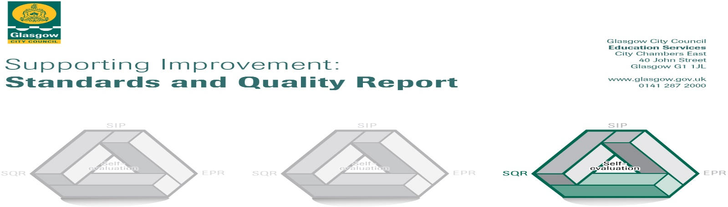

The summary report is provided for parents/careers and partners to outline our achievements this session and our priorities for next session. Throughout this session we have taken forward our priorities as detailed in our school improvement plan. Through our processes of self-evaluation, we have identified how we can improve outcomes for our children and young people.

Our achievements and improvements this year.
We would like to highlight the following improvements/achievements:
Following the fire in December 2017 and the loss of our gymhall/fuel zone annexe everyone worked hard, through a series of disruptions, to provide continuity of learning and teaching, school events and community engagement. We worked closely with our Cordia partners to provide a breakfast service and lunches, with MACS after school care to continue the 3.00 to 6.00pm childcare service and with GCC Education Services to arrange for temporary facilities. We hope to have a temporary gymhall which will also be used for Cordia breakfast service and for fuelzone lunches ready in August 2018.
Children, parents, staff and other partners worked together to achieve:
- PE and sports – Football trophy winners, Badminton finalists, Athletics all Glasgow finalists and medal winners, range of other sports netball, table tennis, running, tennis, rugby, cross country, triathlon and Glasgow Gymnastics and other events.
- Fairtrade Week and award, Health Week on the theme of the European Championships, Finance Week, World Book Day, First Minister’s Reading Challenge award,
- Our class enterprise projects and the Friday healthy tuck shop
- Sharing Learning events across all stages
- Raising trout in P5 and butterflies in P2
- Music performances for our choirs and our music evening for our recorder group and choirs.
- School plays P1-3 Nativity, P7 – Edith’s War , P3 – Eddie the Penguin Saves the World.
- Clubs – dance, gymnastics, athletics, football, choir, glee club, recorders, table tennis, rugby, netball, family book clubs, writing, ipad video making, Lego,
- Charity fundraising events
- PTA family events and fundraising. The funds have subsidised school trips and visits, bought ICT equipment including replacement projectors and ipads, furniture and other resources.
Our overall attainment in literacy and maths was:
- Talking and Listening – 92%
- Reading – 88%
- Writing – 77%
- Maths – 83%

Here is what we plan to improve next year.
- Raising Attainment – Literacy and Maths, Family Learning, Early Years approaches, Teacher learning Communities

Literacy – Continue to develop the Literacy programme for Reading and Writing and focus on Talking and Listening – in line with our Raising Attainment and Public Equity Funding plans

Maths – introduce the Glasgow Counts planning and tracking overviews, continue to develop the Glasgow Counts learning and teaching approaches across the school

Early Years learning through play – take the approaches forward into P2

Continue to support staff development through the Tapestry Teacher Learning Communities

Continue to develop through Family Learning clubs, events and with a homework review

- Moderation and Assessment – Continue to build capacity covering SNSA, Benchmarks, Pupil Progress report format and informing parents, pupil learning conversations

- Ethos – implement the consequences approach across the school and continue to develop Growth Mind-set and investigate Mindfulness approaches

How can you find out more information about our school?
Please contact us directly if you require further information or if you wish to comment on the report.

The contact e-mail address is: headteacher@scotstoun-pri.glasgow.sch.uk

Our telephone number is: 0141 959 3247

Our school address is: Scotstoun Primary School, 21, Duncan Avenue, Glasgow, G14 9HN

Our school website is: www.scotstoun-pri.glasgow.sch.uk

Our school twitter is: @scotstoun

Further information is available in: newsletters, the school website, and the school handbook

