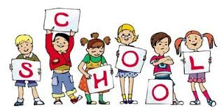
Curriculum Newsletter for Parents/Carers of P2
Literacy  Reading –  The children will be looking at the features of a variety of poetry. After the February break we will be reading about the adventures of Katie Morag.  Home reading books will be changed each Wednesday. The children will be focusing on comprehension skills this term.  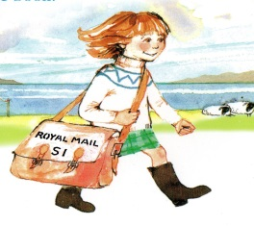  Writing – The children will be writing their own rhyming and non-rhyming poetry.  After the February break, writing skills will be linked to the Katie Morag stories.  Talking and Listening – The children will be learning lots of different poems this term. To link with Robert Burns Day, we will be asking them to recite a simple Scottish poem learned in class. | Numeracy  This term will have a money focus. The children will make totals and give change. They will investigate how different coins make the same amounts of money (up to £1).  We will also be working on time. The children will use both analogue and digital clocks to read and record different times as well as answer time related questions.  As always, we will continue to work on our number bonds and addition and subtraction skills.  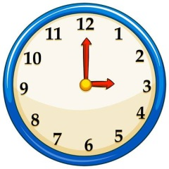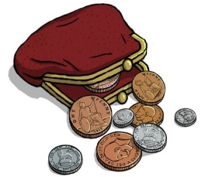
Miscellaneous
P.E.
Our gym days are on a Monday and Wednesday; please ensure your child has a fully equipped gym kit on these days. For safety reasons please also ensure they are not wearing any jewellery.

New home learning grids and spelling lists will be issued at the beginning of term so please look for them in your child’s folder.

Parent teacher meetings are on Wednesday 20th and Thursday 21st February (times to be issued). We look forward to seeing you then.

Thank you for your continued support,
Miss Waters and Mrs Whyte
Social Studies

The term will be split into two topics. For the first part of the term the class will be continuing their work on farming and we will be asking the children to work together in groups to make a farming community. They will have to plan, grow and sell their own produce (pretend). We plan to visit a real farm to see what life on the farm is really like (date to be confirmed).

After the February break, the class are going to decide on their own topic for the class to learn about.

