
Scotstoun Primary School Primary 1 News Letter April 2019

Welcome to term 4. We hope you find the following information helpful and interesting!

Literacy

This term we will be looking at the novel ‘A Balloon for Grandad’ which will link to our topic on countries around the world. As well as looking at character, plot and in particular setting, the children will have lots of opportunity to read and learn about countries around the world when looking at non- fiction books in class. If you have any books about animals, houses, climate or children’s atlases that we could borrow for the duration of the topic, please send them into school (remember to label them first.) Thank you.

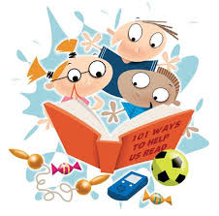
Maths
This term the children will be actively involved working with numbers to 20 and beyond for some. Our work on addition and subtraction will continue too and we would urge you to keep practising adding and subtracting within 10 at home to help your child consolidate these processes and learn the number stories. We will be working on money buying, adding and change using shopkeeper’s addition (adding on from the price). As usual, the children will use various active methods including ICT programmes, games and other materials.

***

Social Studies /Global Citizenship

Using our novel ‘A Balloon for Grandad’, the children will learn about countries around the world, including their own. We will learn about climate, homes, food and animals. As part of the children’s learning, we will be visiting Blair Drummond Safari Park and the children are excited to be going on such a lovely trip. We are very happy to inform you that we will be having an open afternoon on Friday 14th June at 1.30p.m. when you will be invited along to share your child’s learning by having a look around the beautiful classroom displays and other work they have done . Please keep this date free in your diary.

Health and Well Being

This term we will be looking at personal hygiene and healthy eating. The children have used the ‘Shanarri well- being wheel’ to help them choose their targets for this term.



Targets and Learning Logs

We are in the process of setting targets for this term. Please take time to discuss the targets your child has set when the learning logs come home and encourage them to remember them when completing homework tasks too. Please also fill in any achievements your child has met (anything from badges at Rainbows, B.B, G.B, Beavers, swimming to learning to tie their own shoe laces!)


Shared Home Learning
As with previous terms the children will receive phonics and tricky words to practise at home. Please continue to practise these. We hope you have enjoyed completing the tasks on the shared home learning wall. We would ask you to keep them in their folders so that we can check and update when needed.
Once again can we stress the following:-
Homework will be put into the children’s homework folders along with any correspondence from the school. It is important that you check this each day and also to ensure your child brings the folder to school every day. Reading books with reading marker jotters should be kept in these folders too and brought to school every day. It would be good for your child to be encouraged to check their own school bag each morning to ensure they have everything they need for the day. Thank you.

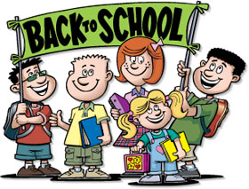
Many thanks for your continued support.
Mrs Rogers and Primary 1A
Mrs Robertson Primary 1B

