
Scotstoun Primary School Primary 1 News Letter January 2019

Welcome to Term 3.

Language

As the children become more confident using their phonic knowledge they will be encouraged to read different genres, for example non- fiction books, alongside their home readers. Please take the time to sign/comment your child’s progress.
We would encourage you to keep checking sounds books for new sounds, practise those and continue to revise all sounds already learned. Tricky words will continue to be added into word boxes with each child working at their own pace to learn these. We are encouraging the children to transfer their knowledge of letter routes into all their writing. This term we will introduce ‘Big Writing’ and the children will be learning how to improve simple sentence structure by using conjunctions, punctuation and to think about appropriate and more complicated vocabulary.
For World Book Week, we will be looking at Julia Donaldson stories. The children will be asked to dress up as their favourite character – more details will follow.

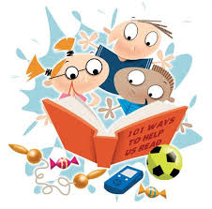
Maths
The children will continue learning about numbers in an active way through games and activities including ICT programmes provided for them to choose from helping them to lead their own learning. Activities will include addition and subtraction, working with bigger numbers, money, time, measure and data handling.


Science
We will be learning about toys and forces and this term. If you have any good quality toys that move by push, pull, twist or that float that you no longer want and could donate them to help with our topic, please let us know.

Social Studies
Later this term we will be using our Time Travelling Machines to travel to the 1960s and discover what life was like then. If you have any artefacts relating to that period of time that we could borrow it would be most appreciated.

Music
We will be using ‘Charanga’ an ICT music programme to enhance our music lessons this term. The children will learn more about pulse, rhythm and playing musical instruments in a fun and active way.


Health and Well Being
We will be concentrating on the theme of Resilience and how to ‘bounce back’ during our lessons this term. The children have been excited to think about and set their own targets for maths, language and HWB and will be selecting items to include in their learning logs.

Homework
As with previous terms the children will receive phonics and tricky words to practise at home. We hope you have enjoyed completing the tasks in the learning wall and the children will be issued with a new and more challenging one this term. We would ask you to keep the sheet in the children’s folders so that we can check when needed.
Once again can we stress the following:-
Homework will be put into the children’s homework folders along with any correspondence from the school. It is important that you check this each day and also to ensure your child brings the folder to school every day. Reading books with reading marker jotters should be kept in these folders too and brought to school every day. It would be good for your child to be encouraged to check their own school bag each day to ensure they have everything they need for the day. Thank you.

Many thanks for your continued support. We look forward to seeing you at various times in the year- in particular this term at our open afternoon (details to follow).

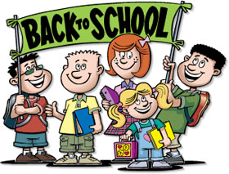
Mrs Robertson, Mrs Rogers and Primary 1

