

Class News

Welcome to Primary 3/4 with Mr. Egan!
with

Scotstoun Primary Term 1

Topic
This term we will be learning about the Vikings.
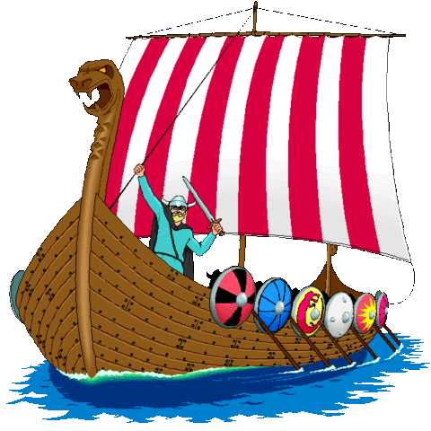We will be having a P3/4 Open Afternoon on Wednesday the 3rd of October to share our learning. Pupils are asked to come dressed as a Viking for a special Viking feast.
Parents and family members are invited along to join us at 2pm to view their child’s work and participate in some Viking themed activities!
P.E
Primary 3/4 PE days are Wednesday and Thursday.

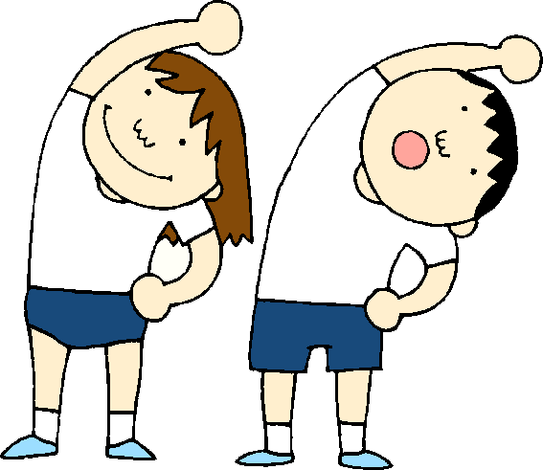
P.E
Primary 3/4 P.E
days are
Wednesdays and Thursdays.



Golden Time
Golden Time will take place on Friday afternoons.
We will be enjoying a range of activities from decorating biscuits, to making playdough and slime!
Please try to keep to the School Values and Golden Rules.

Literacy
This term we will be focusing on characterisation and recount writing.

Numeracy
We will be focusing on a range of maths concepts this term. Please remember to practise your times tables at home!

Dates for your Diary:

P3/4 Viking Open Afternoon
Wednesday 3rd of October

