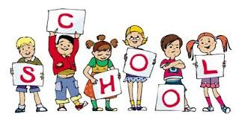
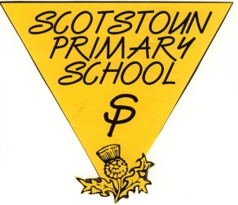
Curriculum Newsletter for Parents/Carers of P2b
Literacy  Reading - The main focus this term is looking at non-fiction texts, where the children will be reading about a variety of different topics. Please ensure your child brings their reading book to school each day.  Writing – This term the children are learning how to write their own reports and fact-files, focusing on birds, plants and minibeasts.  Talking and Listening – The focus this term is on gathering information about endangered bees. Children will not only report on the facts but will also be encouraged to offer their opinions about how we can help them! | Numeracy  This term the children will be learning about a variety of concepts in Numeracy.  There will be the opportunity for learning experiences in exploring 2D and 3D shape within and outside the classroom, including aspects such as symmetry and position.  We will also be looking at number sequences to 1000, counting on and back in ones, tens and one hundreds.  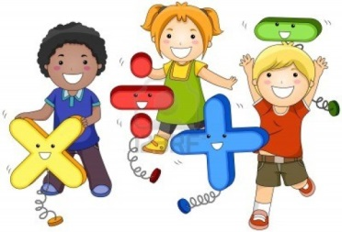
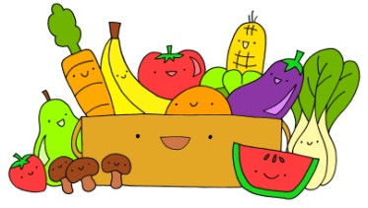
Key Dates

Minibeast trip – We will be going to Kelvingrove park on a Minibeast Safari on the morning of Wednesday 29th May. We would be very grateful for any volunteers who could come along and help! Letters will be sent home nearer the time.

Open Afternoon - Our open afternoon will be on Tuesday the 4th June between 2pm -3pm. The children are looking forward to showing off their learning in their topic work on birds, plants and minibeasts. It will be a fun afternoon!

Health Week – Health week will be commencing on the 20th May, where lessons will be focused around mindfulness and wellbeing for the duration of that week.
Science

We will be exploring the world of birds, plants and minibeasts this term. This will be a very hands-on topic, where the children will be growing their own plants, making bird feeders and looking after caterpillars as they eventually transform into butterflies. Great fun!

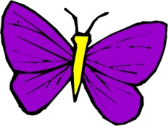
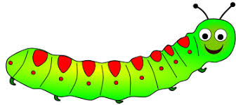
P2 Class Teachers

