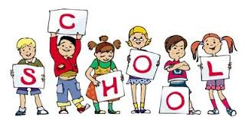****Primary 3a

September Newsletter

**Parent’s Open Evening**

It was lovely to meet so many of you at our recent Open Evening. The children were very excited to show you around their classroom and share their learning on the classroom walls. I hope you enjoyed the PowerPoint showing how hard the children have been working in class.

The children have now all settled into their 1st term in P.3a and are all working very hard. Our gym days are **Tuesday** and **Thursday**. I already have some new unnamed sweaters in the classroom that have been left in school. Please could I remind you to put your child’s name on all their uniform including their P.E kit.

Thank you.





The children have thoroughly enjoyed listening to The Lighthouse Keepers Lunch story. They have learned some new and interesting vocabulary and have also been using the story in our literacy lessons. The best part, no doubt, was making Mr Grinling’s sandwiches!!

I look forward to meeting you all at our Parents Night on 9th or 10th October.

Mrs Gough

**Language**: This term, we have all been practising our spelling patterns and using them in interesting sentences. We have also been practising saying the alphabet regularly and learning about the vowels.

**Numeracy**: In numeracy, we are learning to count in 3s in preparation for the multiplication tables. Please encourage your child to practise these regularly at home. Thank you.