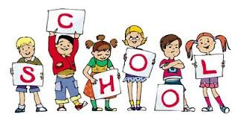****Primary 3a

January Newsletter

**Language**: Our main focus in writing this term is looking at poetry. We will be learning some poems by Scottish poets and well as trying to write our own riddles!

**Afternoon Snack:** I am aware that our afternoon is a long time for our young learners to work without a break and I would like to suggest that the children bring a small piece of fruit or snack which we will eat in the middle of the afternoon in the classroom.

**Numeracy**: In numeracy, the children have recently been enjoying learning about fractions. We will continue to work on a variety of numeracy skills this term including dividing, learning the 6 times table, telling the time using analogue and digital clocks and reading, writing, sequencing and adding numbers within 1000.

**Social Studies**: We have 2 topics this term. Firstly, the children will be budding scientists and will be learning about magnetism. They will conclude this topic by designing and making their own magnetic fishing game. **Please can you send in any old shoeboxes.**

We will then be learning about Scottish Castles and this topic will involve an exciting visit to Stirling castle 0n Tuesday 12th March.

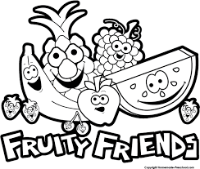

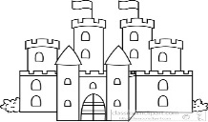

I look forward to meeting you all again at our parents’ evenings in February.

Mrs Gough