Our Child Protection Co-ordinators are:

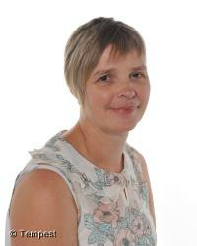
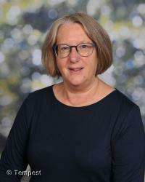

Mrs Mackay Mrs Coats

If Mrs Mackay and Mrs Coats are not available,
contact Mrs Gordon (DHT) or Mrs McKinnon (PT)

