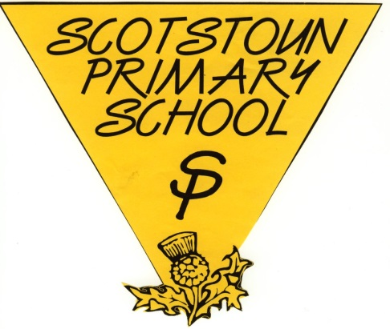
Child Protection and Safeguarding
The difference between child abuse and child protection could be you.

At Scotstoun Primary School our Child Protection Co-ordinators are:
Gill Mackay (Head Teacher)
Alison Coats (Deputy Head Teacher)

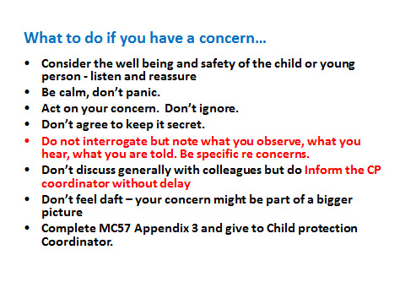

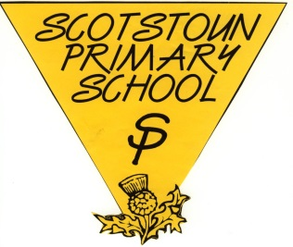
Child Protection and Safeguarding
The difference between child abuse and child protection could be you.
At Scotstoun Primary School our Child Protection Co-ordinators are:
Gill Mackay (Head Teacher)
Alison Coats (Deputy Head Teacher)

